**Charotar University of Science and Technology [CHARUSAT]**

**Chandubhai S. Patel Institute of Technology [CSPIT]**

**U & P U. Patel Department of Computer Engineering**

**Lab Manual**

|  |  |  |  |  |  |  |  |  |
| --- | --- | --- | --- | --- | --- | --- | --- | --- |
| Subject code | : | CE-350 | Semester | : | 6 | Academic Year | : | 2021 |
| Subject name | : | Data Warehouse and Data Mining | | | | | | |

**Practical – 6**

**Aim:**

**Generating Classification Tree -Decision Trees, Cross Validation**

* **Prerequisite**

S/W: - Anaconda, Jupyter Notebook

Little bit knowledge about the Jupyter Notebook and how it works on Data Mining.

* **Step to install Orange Tool:**

1: [Download the Anaconda installer](https://www.anaconda.com/download/#windows).



2: RECOMMENDED: [Verify data integrity with SHA-256](https://docs.anaconda.com/anaconda/install/hashes/). For more information on hashes, see [what about cryptographic hash verification?](https://conda.io/projects/conda/en/latest/user-guide/install/download.html#cryptographic-hash-verification)

3: Double click the installer to launch.

**Note**

To prevent permission errors, do not launch the installer from the [Favorites folder](https://docs.anaconda.com/anaconda/user-guide/troubleshooting/#distro-troubleshooting-favorites-folder).

**Note**

If you encounter issues during installation, temporarily disable your anti-virus software during install, then re-enable it after the installation concludes. If you installed for all users, uninstall Anaconda and re-install it for your user only and try again.

4: Click Next.

5: Read the licensing terms and click “I Agree”.

6: Select an install for “Just Me” unless you’re installing for all users (which requires Windows Administrator privileges) and click Next.

7: Select a destination folder to install Anaconda and click the Next button. See [FAQ](https://docs.anaconda.com/anaconda/user-guide/faq/#distribution-faq-windows-folder).

**Note**

Install Anaconda to a directory path that does not contain spaces or unicode characters.

**Note**

Do not install as Administrator unless admin privileges are required.

[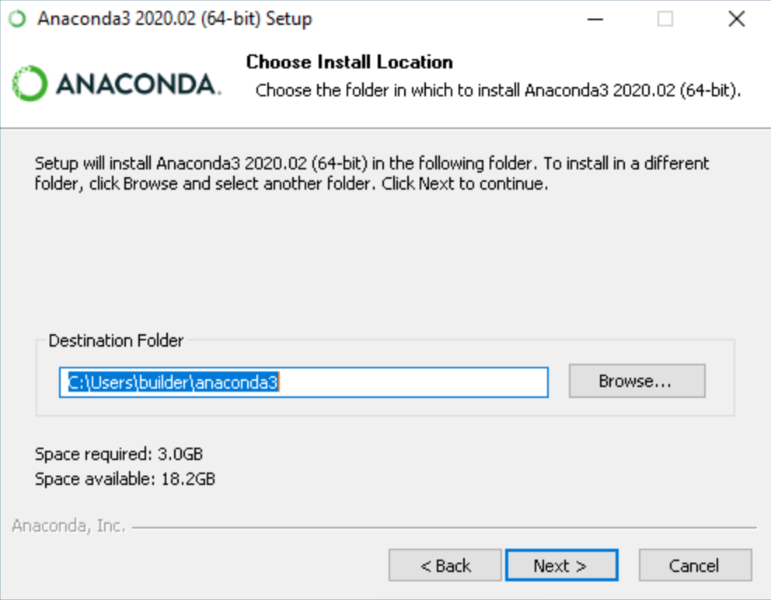](https://docs.anaconda.com/_images/win-install-destination.png)

8: Choose whether to add Anaconda to your PATH environment variable. We recommend not adding Anaconda to the PATH environment variable, since this can interfere with other software. Instead, use Anaconda software by opening Anaconda Navigator or the Anaconda Prompt from the Start Menu.

[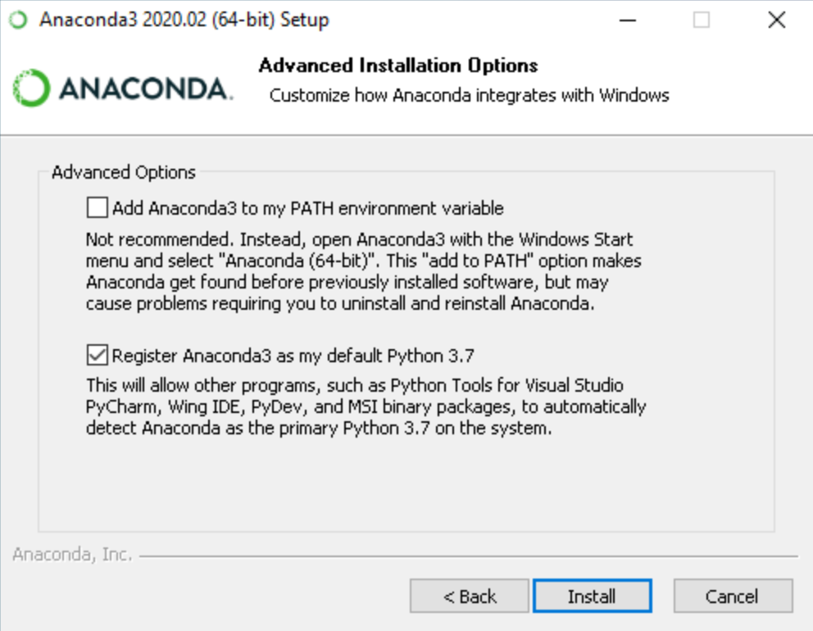](https://docs.anaconda.com/_images/win-install-options.png)

9: Choose whether to register Anaconda as your default Python. Unless you plan on installing and running multiple versions of Anaconda or multiple versions of Python, accept the default and leave this box checked.

10: Click the Install button. If you want to watch the packages Anaconda is installing, click Show Details.

11: Click the Next button.

[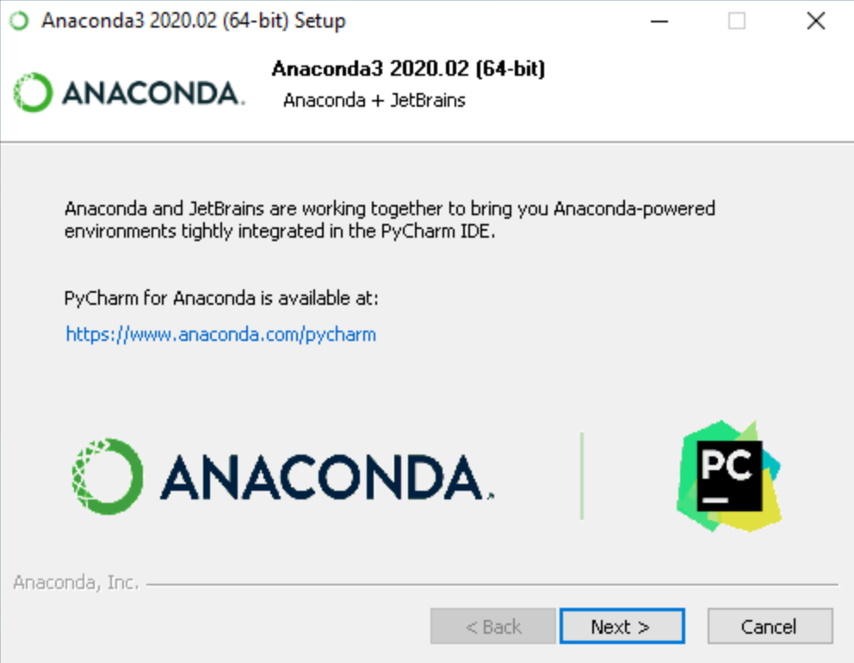](https://docs.anaconda.com/_images/win-install-pycharm.png)

12: After a successful installation you will see the “Thanks for installing Anaconda” dialog box:

[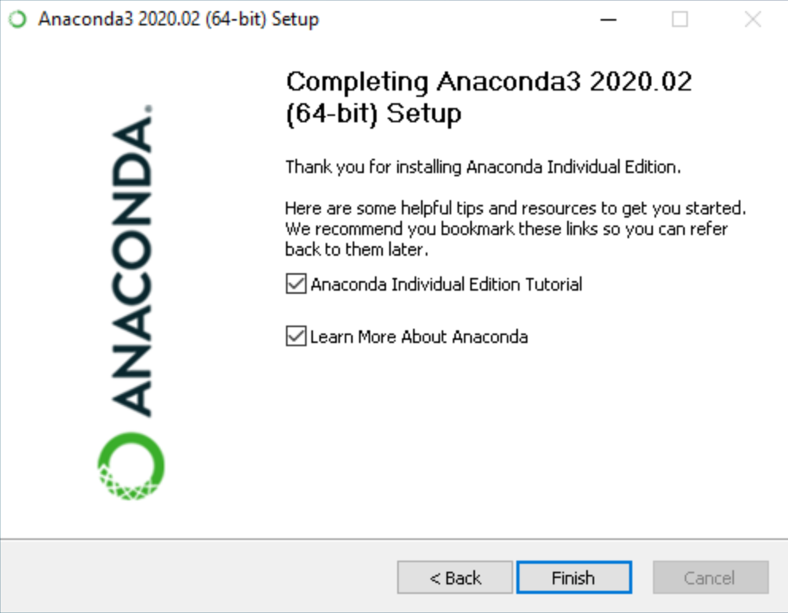](https://docs.anaconda.com/_images/win-install-complete.png)

13: Click the Finish button.

14: [Verify your installation](https://docs.anaconda.com/anaconda/install/verify-install/).

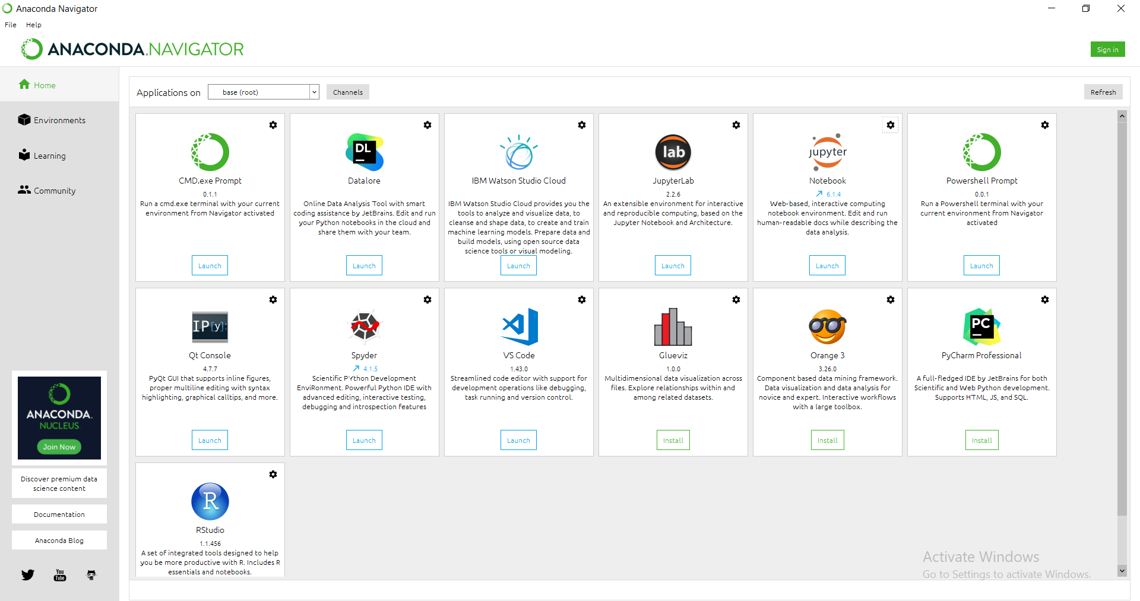

* **Algorithm / process flow:**

1. Import pandas and linear_model from sklearn

2. Convert csv file into dataframe

3. Handling Missing Values

a. Identify NaN in columns

b. Replace missing values with fillna()

4. Drop index column (Serial No.)

5. Dimensional Reduction

a. Prepare test_dataset

b. Select train_dataset

6. Apply linear regression and prepare model by finding best fit line

7. Predict ‘Chance of Admit’ on the basis of model and given input values

8. Print the predicted value

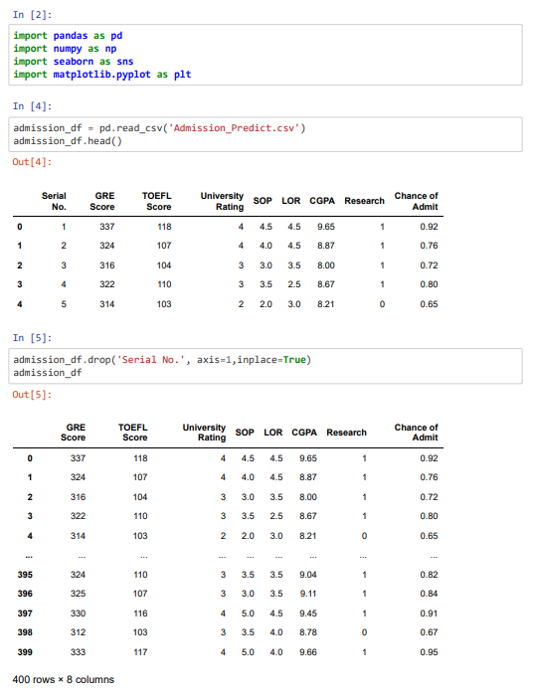

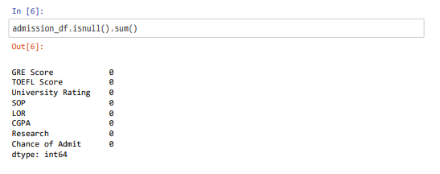

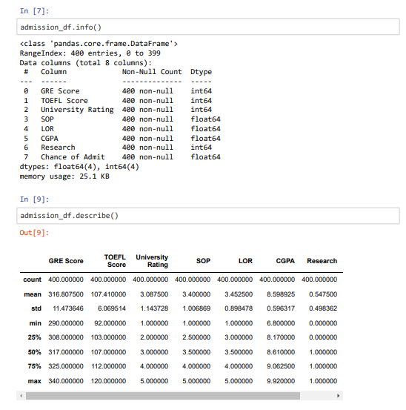

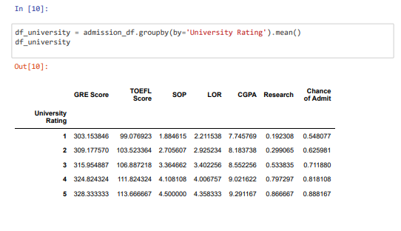



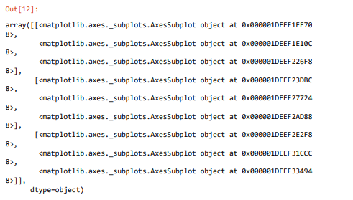

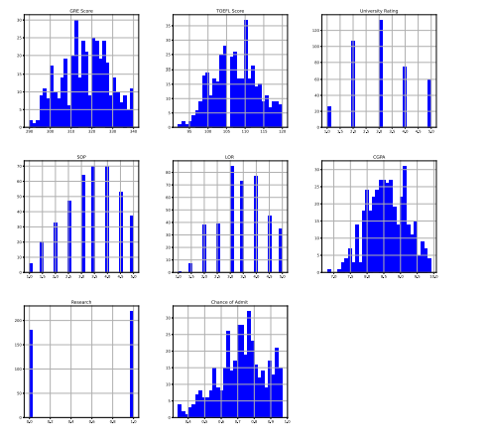

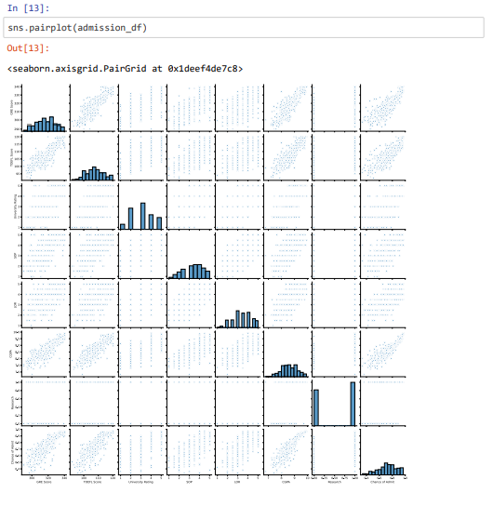

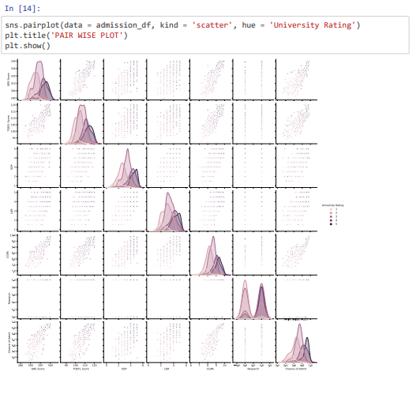

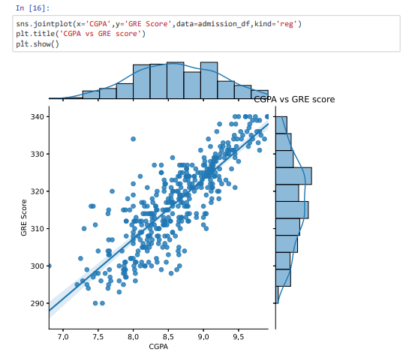

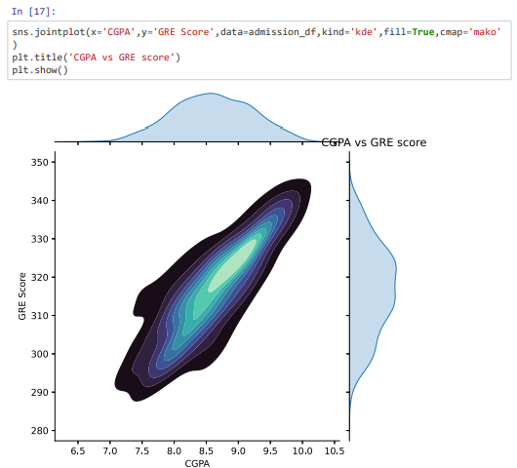

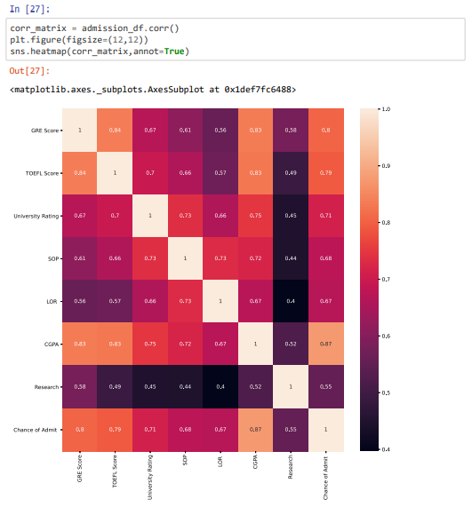

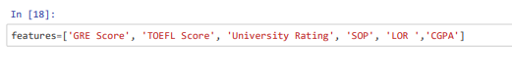

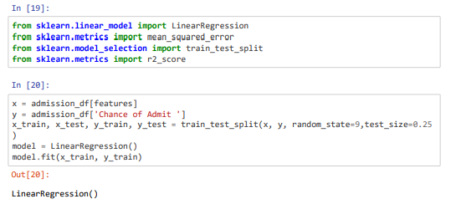

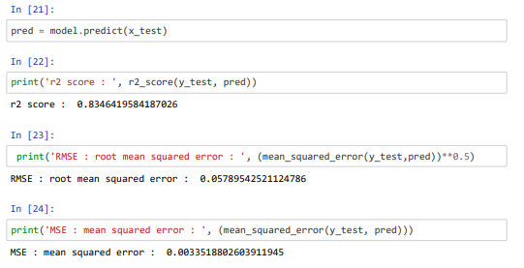

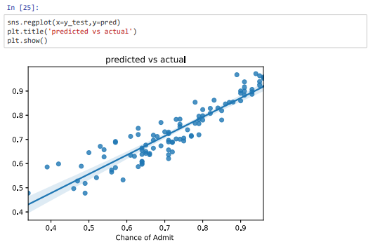

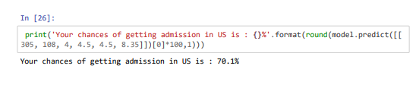

* **References:**
  + [http://education.abcom.com/admit-prediction/](http://education.abcom.com/admit-prediction/%20)
  + <https://www.youtube.com/watch?v=JrIo06yYXyg&t=1s>
* **Question & Answers:**

**How to fill empty cells?**

Pandas provide fillna() function to fill empty values

**How to drop columns?**

Pandas provide drop() to drop columns or rows. To drop column specify axis=1 oraxis=‘columns’

**How to find coefficient of the best fit line?** coef_ of linear_model.LinearRegression() gives coefficient’s value

**How to find coefficient of the best fit line?**intercept_ of linear_model.LinearRegression() gives intercept’s value

**How to predict values for given input values?**

Use predict() method of linear_model.LinearRegression() to get predicted value froma test model

* **Conclusion :**

From this practical we have learnt scikit-learn library in Python by practically performing linear regression on a dataset imported from .csv files into Jupyter Notebooks.

|  |  |  |  |
| --- | --- | --- | --- |
| **Prepared By:** | Rajiv Kumar Gupta (18CE137) | **Date:** | 04-012-2021 |